**Plate Notes**

* Plates – broken pieces of lithosphere.

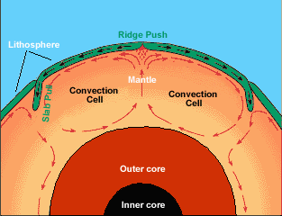

* Theory of plate tectonics – states that pieces of Earth’s lithosphere are in slow, constant motion, driven by **convection currents.**

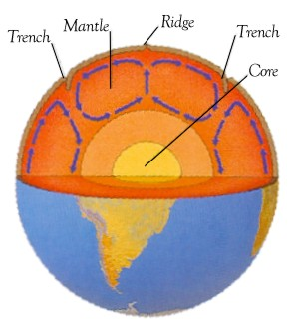

* The Mantles constant motion drives the plates.

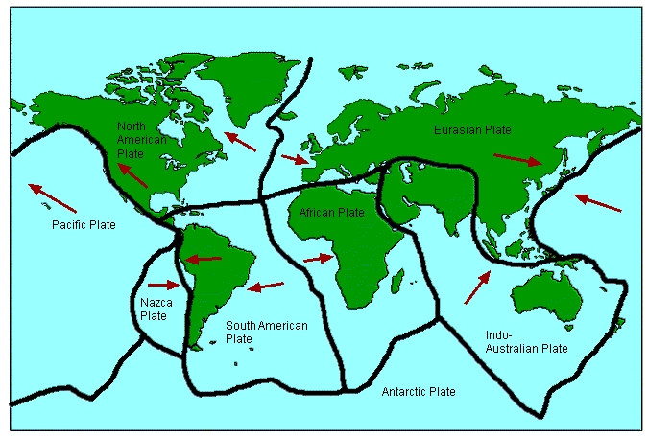

* Plate boundaries are where plates meet.
  + - Tectonic activities such as volcanoes, mountains, earthquakes and many other activities occur here.

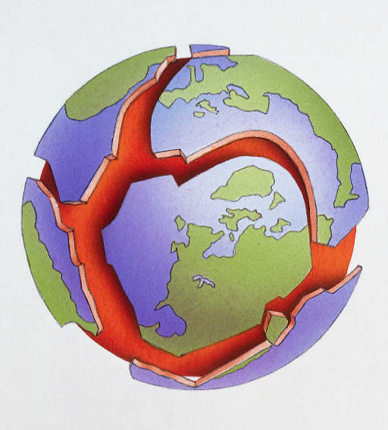

* 1. Divergent Boundaries - plates that move apart
  + Causes rift valleys, sea floor spreading, mid-ocean ridges.
* 2. Convergent Boundaries - plates that move toward each other.
  + Cause subduction zones, trenches, mountains, volcanoes.
* 3. Transform Boundaries - plates that slide against each other
  + Causes earthquakes